1.Create product_price_audit table:

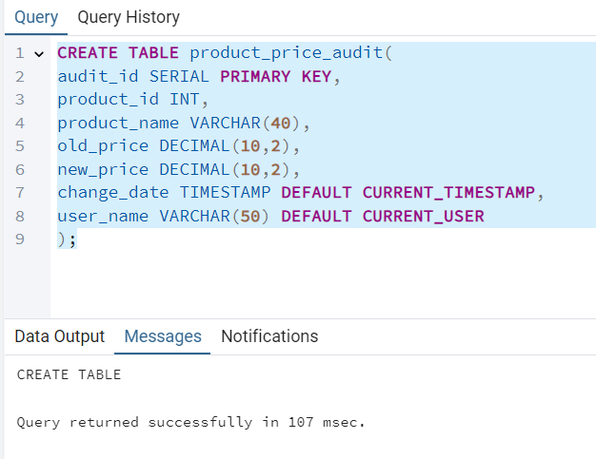

Create a trigger function:

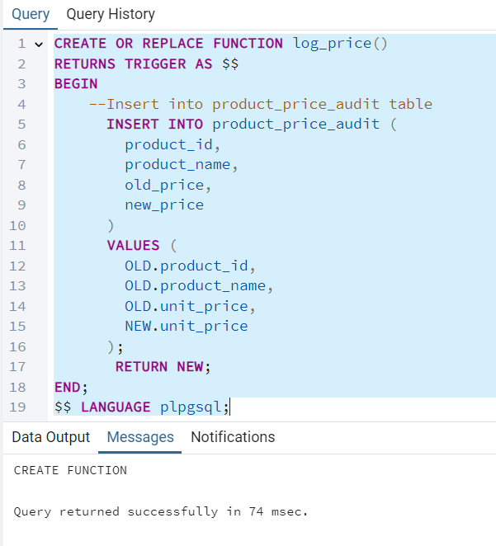

Create a row level trigger for below event:

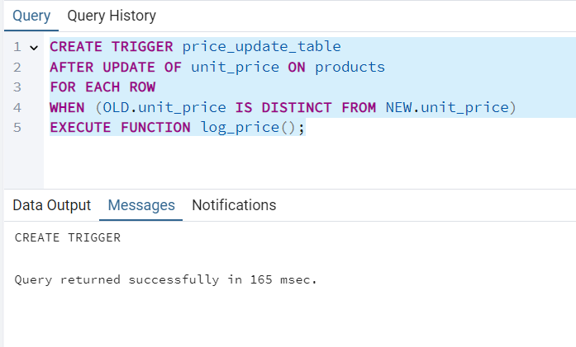

Test the trigger by updating the product price by 10% to any one product_id:

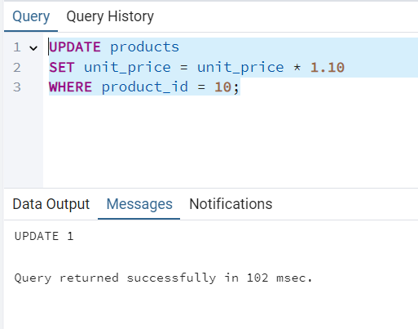

Select the updated product_id:

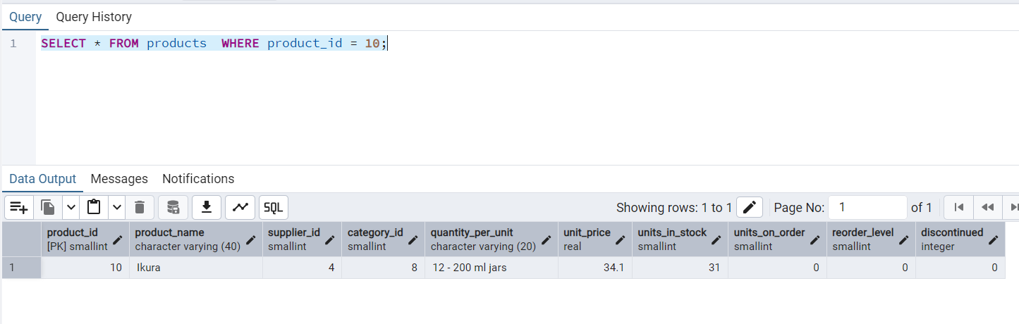

Verify the product_price_audit table:

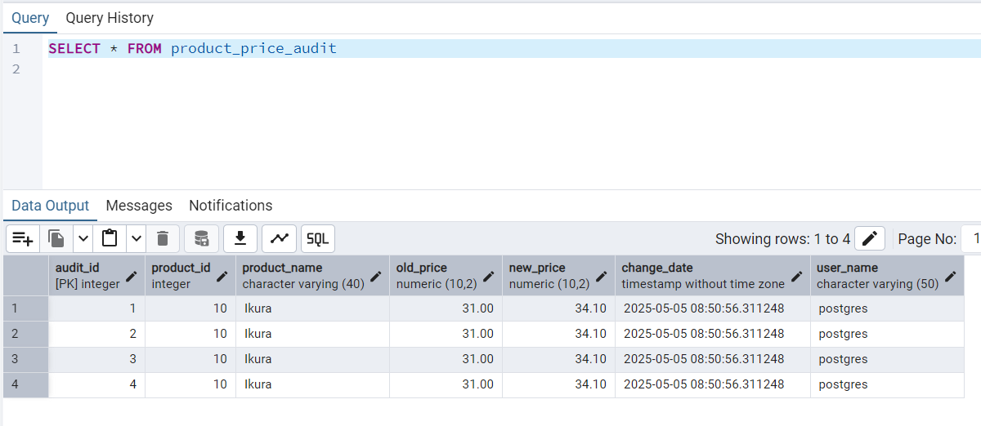

2.Create stored procedure using IN and INOUT parameters to assign tasks to employees:

Create employee_task table

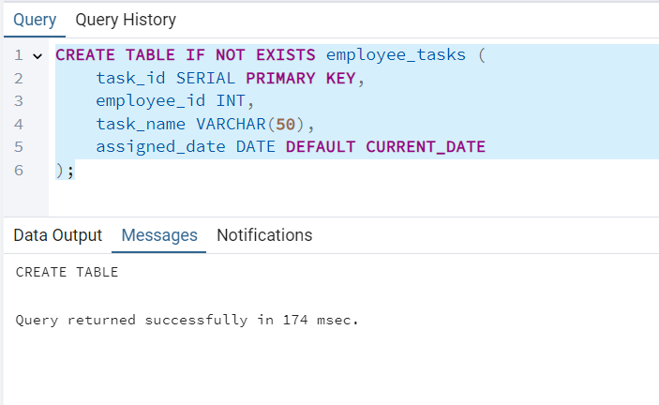

Create Stored Procedure

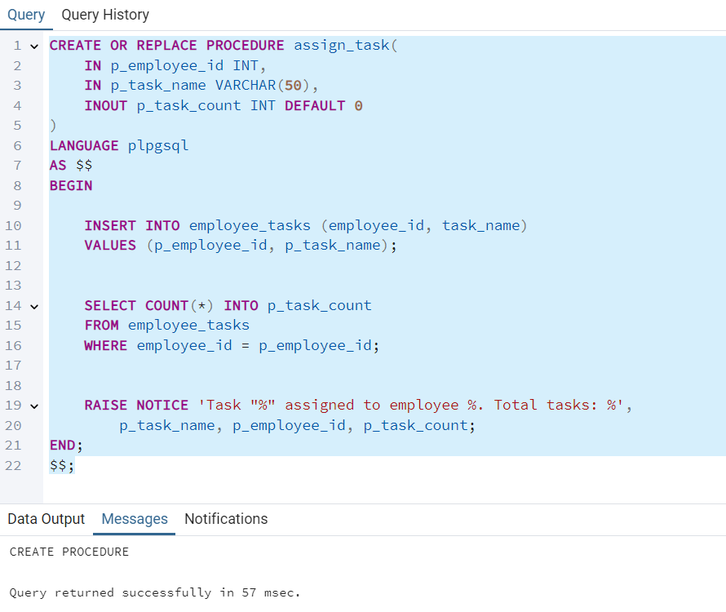

After creating stored procedure test by calling it:

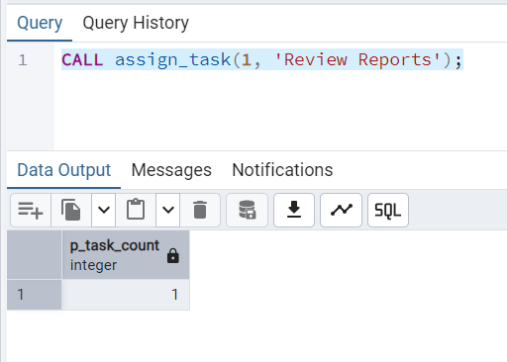

See the entry in employee_tasks table: